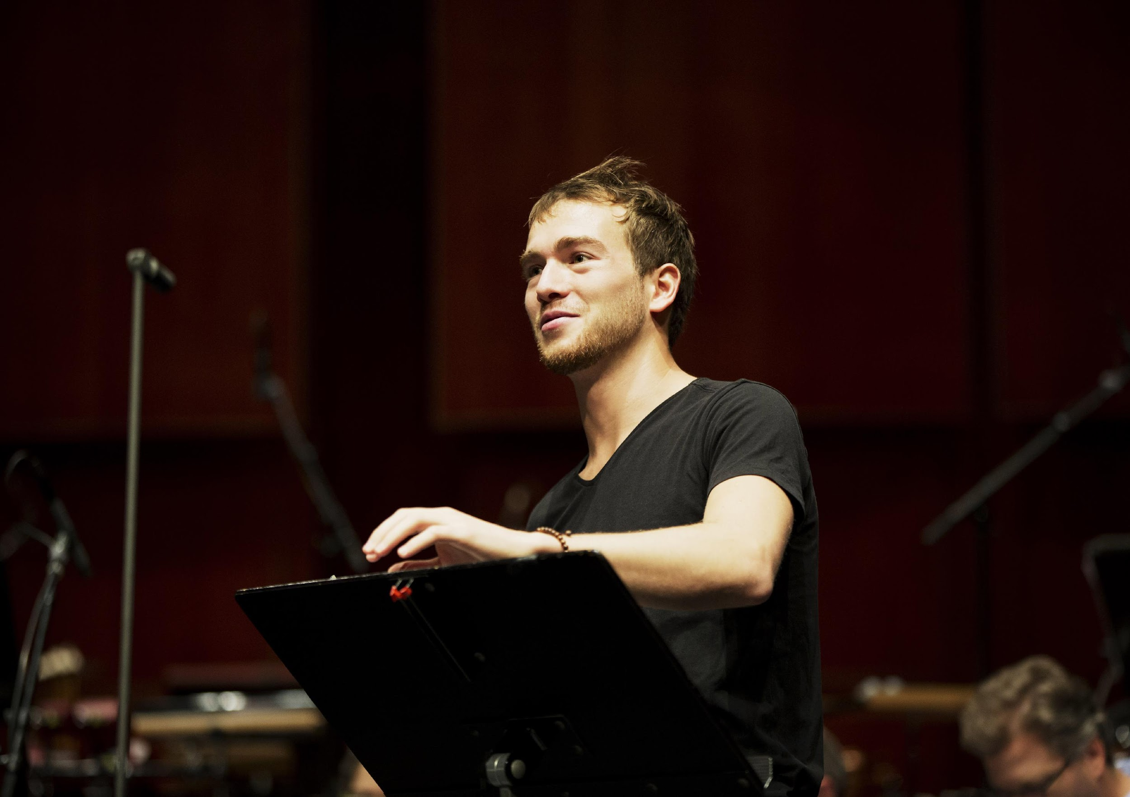
Born in a small village in the North of France, Joë Christophe discovered music at a very young age thanks to a free of charge music school and the wind band that lent him his first instrument. He quickly managed to become one of the best clarinetists of his generation by entering the Conservatoire National Supérieur de Musique de Paris and winning numerous competitions and auditions during his studies.
In 2019, Joë Christophe confirms his artistic singularity by winning the 1st Prize at the Cluj International Competition in Romania, and, the following month, the 1st Prize as well as 6 special prizes at the very prestigious ARD competition in Munich, launching his carrer as a soloist to an international stage. He finished his studies at the Conservatory the following year with the highest distinctions.
He has had the opportunity to play in some of the world's most prestigious concert halls, such as the Philharmonie de Paris, Wiener Musikverein and Konzerthaus, Kölner Philharmonie, Berliner Konzerthaus and Philharmonie, Munich Prinzregententheater and Herkulessaal, Stiftung Mozarteum Salzburg, Tokyo International Forum and Opera City Concert Hall.
He has been invited to perform as a soloist with such renowned orchestras as the Deutsches Symphonie-Orchester Berlin, Münchner Kammerorchester and Münchner Rundfunkorchester, Collegium Musicum Basel, Philharmonie Südwestfalen, Anhaltische Philharmonie Dessau, Orchestre de l'Opéra de Toulon, Orchestre de la Garde républicaine. He has also performed at numerous festivals as a chamber musician, such as the Davos Festival, Nouveaux Horizons Festival, Radio France Montpellier Occitanie Festival, Sonates d'Automne Festival.
​In 2020, Joë Christophe was featured in the famous program Stars von Morgen presented by Rolando Villazón and broadcasted on Arte. In 2021, he participated in the prestigious programme Debüt im Deutschlandfunk Kultur in Berlin, in which artists such as Jacqueline du Pré, Daniel Barenboim and Sir Simon Rattle have participated.
In France, he was nominated in 2023 in the category 'Instrumental Soloist Revelation' at the Victoires de la Musique Classique program.
​His first CD 'Idylle', which he recorded with pianist Vincent Mussat and the German label Genuin Classics, explores the beautiful colours, deep feelings and humour of the French and English repertoire for clarinet and piano.

Ambassador of the wind instrument manufacturer Henri Selmer Paris, Joë Christophe also benefits from the support of the Banque Populaire Foundation since 2022.

www.joe-christophe.com

